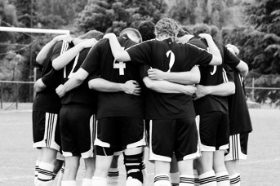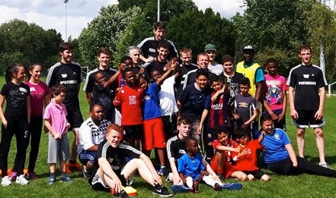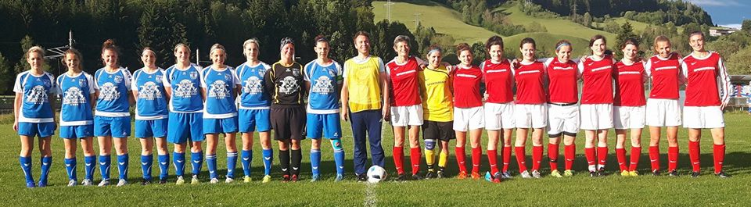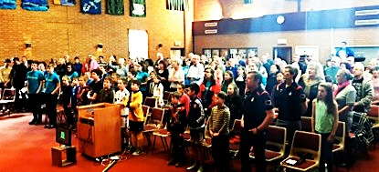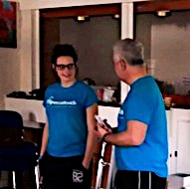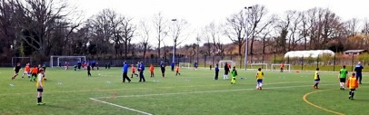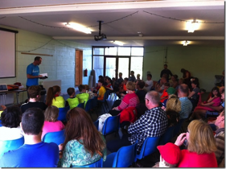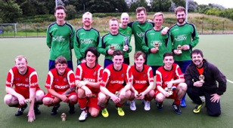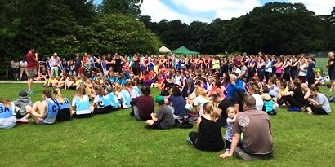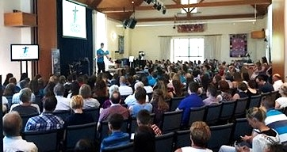

**Team prayer before a match in France**

## Prayer is key; it’s powerful, it’s unique…it’s life changing!

Throughout scripture and throughout history we see the effects of prayer, fervent prayer. Many a battle is won on our knees! Jesus said we are to ask anything in His name so that He can bring glory to the Father – so let’s do just that. Let’s pray together that in the 5 weeks of soccer and netball schools this summer, God will be glorified! Let’s pray that many children will come and have fun playing sport, and as they hear the life-changing news that Jesus saves, may that become a reality in their lives! Ask, seek, knock…

###### Pray for more open doors to take the gospel to the sporting world, and for hearts to be open to the good news wherever we go…to the glory of God!

**Football, fun and faith with kids in Macon**

‘You can ask for anything in my name, and I will do it, so that the Son can bring glory to the Father. Yes, ask me for anything in my name and I will do it!’ John 14:14

**SportsReach Ladies v Pichl Ladies, Austria. Played 3 won 3, but the greatest victory is sharing Jesus with the teams!**

8 matches v local teams

School lessons

Saturday soccer with kids

Devotions

Sharing times

Giving Bibles and literature

Sharing Christ

Praise God for a great tour, and continue to pray big!

France

# Ask…Seek…Knock…

Reaching the world for Christ through sport

SportsReach July 2016

SportsReach July 2016

**Please pray for the 5 weeks of summer soccer and netball schools.**

**A packed church for the Awards Service**

**Coach’s Interview**

Market Harborough…

Working with Harborough Evangelical church, this was our third soccer and netball school in the area. Again a great week, with several young people (including an assistant coach!) giving their hearts to Jesus. Praise God! One highlight is always the coaches v parents match in the netball section, and this year was no exception! Always competitive and always a lot of fun – a great way to get to know the parents better!

The Sunday morning saw a packed church as parents and families came along to support their children, see them get their awards, sing one of the SportsReach songs, a coach’s interview and hear testimony ‘ from Sue. We thank God for touching lives.

**Sooty interviews Sarah**

The Battle SportsReach netball & soccer school went well in so many ways. Prayers were answered. Fifty-seven children took part, including the largest group of netballers so far. The coaches from north & south quickly bonded into an effective team who supported each another well. The Church were fantastic at providing all the human & financial resources needed to run this exciting venture. The pray-ers, caterers, coaches, hosts, & the set & clear up teams all played their part with great energy & grace.  And God was merciful to us with the weather…especially with the World Cup matches & BBQ on the Saturday given the dreadful forecast. We enjoyed good relations with the young people at all times, & we also related well with the parents & carers in our contacts with them.

Spiritually speaking, the event went well too. The morning devotions were excellent. We looked at Christ through the Old Testament events of Joshua, Abraham (& Isaac), Job & David (& Goliath) in fresh & revealing ways - solid discipleship & preparation for the coaches. This year’s theme for the youngsters was “Jesus - The Game Changer”. Although referees, managers, substitutes etc. all may change a football game … it’s Jesus that changes lives. Youngsters came closer to Jesus & have started to read the Bible. There were 2 new commitments & 17 re-commitments… & the awards service was definitely engaging. The whole week gave the young people & their families a very positive experience with sport & the Good News of Jesus Christ. Please pray for Battle Baptist Church as it follows up the written responses, & also 3 other families whose children loved SportsReach so much, they want to start coming to church. May they find Jesus too!

**Tim sharing with the children and parents**

This was an amazing soccer school! For me, the highlights of the week were many- notably one youngster from one of the estates in Ipswich becoming a Christian. The day before, he had hesitated when given the opportunity to go into a group finding out more about becoming a Christian, watching from afar at the door but choosing instead to play football. This day, he made the decision to go into the group saying he had wanted to do this for a long time but never really knew what to say. Praise God! Another told me over lunch that in the morning before he arrived he had given his life to Jesus. Praise God!  Many parents told me how much their children loved the week, and even one parent saying her son who was very shy had enjoyed it immensely which is so encouraging to hear.  When God is in the centre, many blessings abound!  Thank you Lord for an amazing week. Roll on next year! *Tim Slater*

Stowmarket Soccer School June ‘16

# Soccer and netball schools…

### Battle SportsReach – 9 years strong

5 Aside Tournament

Saturday 9th July – 13 men’s teams and 3 women’s’ teams came to Lancaster Uni to compete in the tournaments. It was a very wet morning but spirits were not dampened as the matches commenced. In the women’s section, the games were very close but Morecambe Ladies won the day undefeated, with Galgate a close second. Some hard-fought matches in the men’s section – Great Eccleston eventually picked up the trophy, with Kendal coming runners up. A great Gospel message was shared during the afternoon from Michael Cornall. We received this encouragement from one of the managers after the event…”We had 5 guys, from the 8 who played in the tournament, at church today, one for the first time. God is definitely moving! Fantastic work, thanks for all you do!” Thanks for praying, and please pray on!

**Winners and Runners Up at Mens’5Aside**

On the 1st to the 5th of June Caton Soccer and Netball school took place; with 97 children taking part throughout the week. God blessed us with sunshine the whole week meaning the only time we had to go inside was for the meetings. The children were great; listening well on the pitch, in bible time, and in the meetings. There were about 10 children who went into group 1 wanting to know more about Jesus; of which many then made a commitment, asking Jesus to save them and change their lives. It was also encouraging to see many of the children go into group 2, standing up for their faith and resisting the desire to go and play football/netball. The week ended with a service at Brookhouse Methodist Church, with a packed out church and the parents and children again hearing the message of Jesus declared clearly. Overall it was a brilliant week!

Caton…96 Children!

**John sharing the gospel at the netball tournament**

**Another packed church at Brookhouse**

This was our biggest tournament yet! 31 teams in 3 sections – Junior, Novice and Main. Again God blessed us with fantastic weather, and there was a real family atmosphere as girls and ladies competed and families came to support, and almost 400 people gathered at noon for a clear gospel message from John Gorst followed by presentation of awards to Chipping Bobcats (Juniors) and Garstang New Stars (Novice). Winners in the afternoon were Garstang Diamonds for the 7th consecutive year! Well done everyone! We look forward to the league starting in September – please pray for this growing outreach. For more info on joining a team or entering a team in the league, please contact sue@sportsreach.org.uk.

#### Netball tournament north…

We woke up to a grey and dismal morning here in the South with rain forecast from 10 o'clock.  It seemed inevitable that it would rain with thick, dark clouds looming overhead all morning but many prayers went up and no rain came, even though other local areas got a drenching.  Praise God!  And the grey skies didn't dampen the players' enthusiasm with 5 teams giving it their all in the round robin matches.  It finished with SportsReach Whites winning a closely contested final against Marlborough House 20-11.  Half way through the morning, Amanda spoke from Psalm 125 v 1; 'Those who trust in the Lord are like Mount Zion, which cannot be moved, but abides forever.'  She challenged the women to consider whether they had peace in difficult times or if they are they shaken when troubles come and encouraged them to seek their peace in Jesus who offers eternal life.  A great day where we knew and felt blessing from a great God. *Lizzie Hyde*

#### Netball tournament south…

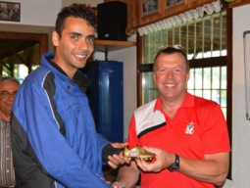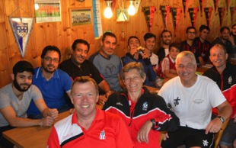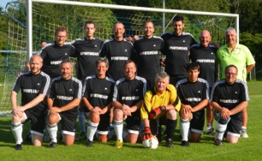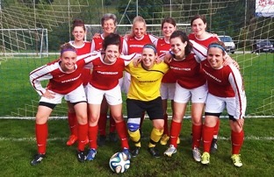

**Making friends – sharing Christ**

**Sharing in the clubhouse with the Syrian refugees**

This was a truly great time! Here are the opportunities the Lord gave us in Erolzheim and Bodenseehof, S Germany.

**Friday** – an early flight from Stansted meant leaving home just after midnight, so a tired classics team arrived in sunny Memmingen, to be greeted by Nico and Rainer. A restful afternoon (and amazing food, thanks Rainer!) was followed by our first match v local team, Kirchberg. A great match. The team put on a bbq for us, and we were there until 11pm chatting, eating, and sharing the gospel!

**Saturday** – our match v Erolzheim was cancelled, so we prayed, and God provided! *AMAZING* opportunity to play Syrian refugees! Afterwards we chatted, and Will shared a very clear gospel illustration with this wholly Muslim team, which was very well received. God provided us with a translator into Arabic from a local church, and also one of the refugees was keen to translate to his team! A VERY MEMORABLE EVENING, please pray for these guys as they read the literature we gave them, and for many more God-given opportunities.

**Sunday –** sharing in the local church about the work of SportsReach, and Sue shared testimony. A wonderful lunch was provided for us afterwards, before we travelled to play against some young men from local churches – another great game and good sharing time afterwards, encouraging them to press on with God, and also share Christ through sport. We then travelled to Bodenseehof for two nights.

**Monday –** Team devotions, sharing time and free time, followed by paying a visit to the local church football training where we briefly shared about SportsReach, then back to the Bible school to share with students and teach them netball!

**Tuesday –** flight back to Stansted, and travel north, tired but rejoicing in what God had done on this first (hopefully first of many) classics tour to Germany. Thank you for praying, and please continue to pray for Nico and friends and the local church in this area. May we see much fruit for this new work.

**The Classics – 1 Austrian,6 Germans,7 English**

Germany Classics 1-5 July

**5 English, 5 Germans, 1 goal – sharing Jesus!**

I love the way God brings these tours together – for the men’s tour, numbers were looking low, but we had a full team for all 8 matches…won 6, drew 1 and lost 1. The shorter girls tour this year played and won 3 matches. We enjoyed Bible teaching at Tauernhof, interaction with the students, team devotions, and sharing the Good News with our friends in Austria. A huge thanks to all our friends at Tauernhof who make these tours possible, and a special thanks to our Heavenly Father who knows and provides all that we need year after year to make these valuable outreaches possible!

Austria tours

Contact us…SportsReach, 57 Lancaster Road, Carnforth, Lancaster, Lancs, LA5 9LE UK. Tel (+44) 01524 730000

Email [office@sportsreach.org.uk](mailto:office@sportsreach.org.uk) Facebook Sports Reach

Website [www.facebook.org.uk](http://www.facebook.org.uk)